
7th February 2025
Dear Parents/Carers,
It has been a busy start to the term so far and we are looking forward to an exciting term ahead.

Dates for your Diary

Monday 10th February – Reception Hearing Tests
Tuesday 11th February – Year 3 Boogie Bounce in School
Wednesday 12th February – Year 1 Infantasia event at Highfield Academy
Wednesday 19th February 2025 – Reception, Year 1 and Year 6 Class Mass 9.30am

Thursday 6th March – Virtual Reality Workshops in school (Reception – Year 6)
Friday 7th March – Hockey Tournament at Raich Carter Centre - 10 children from Year 5
Monday 17th March – Year 3 Bullying and Friendship Workshop
Thursday 27th March – Year 2 visit to Washington Wetlands Centre

Friday 4th April – Year 3 visit to Davenports Chocolate Factory

Jubilee Year 2025

Pope Francis has announced that 2025 will be a year of Jubilee. The Jubilee motto is ‘Pilgrims
of Hope’ and we are invited on a spiritual journey as people of Hope, searching for an ever-deeper connection with God.
We launched the Jubilee Year with a whole school Celebration of the Word. Each child walked through our Holy Door as they left the hall.
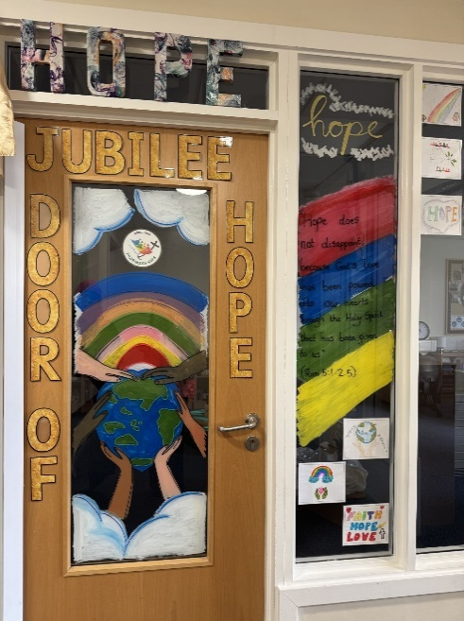


PE Kit
We still have a number of pupils wearing a range of clothing for PE. Again, a reminder that our policy states that the PE kit is school joggers from Little Gems or plain black joggers, PE t-shirt or plain white t-shirt and school sweatshirt. Please ensure that your child wears the appropriate PE kit on their allocated day.

School Ties
Please ensure that your child comes to school in the full uniform including a school tie (Year 1 to Year 6).
Dodgeball Tournament
Some Year 6 children took part in a dodgeball tournament at the Puma Centre last week . . . and our team came first! We are so proud of them!

Hockey Tournament
Some Year 5 children took part in a hockey tournament at St Anthony’s this week . . . and our team came first! We are so proud of them!



SEND Support
If your child has autism, sensory processing or ADHD or you are concerned about your child in relation to these areas but they have no diagnosis, Daisy Chain offer a range of services and support. See attached flyers, contact sunderlandfamilysupport@daisychainproject.co.uk or visit their website https://daisychainproject.co.uk/ for more information.
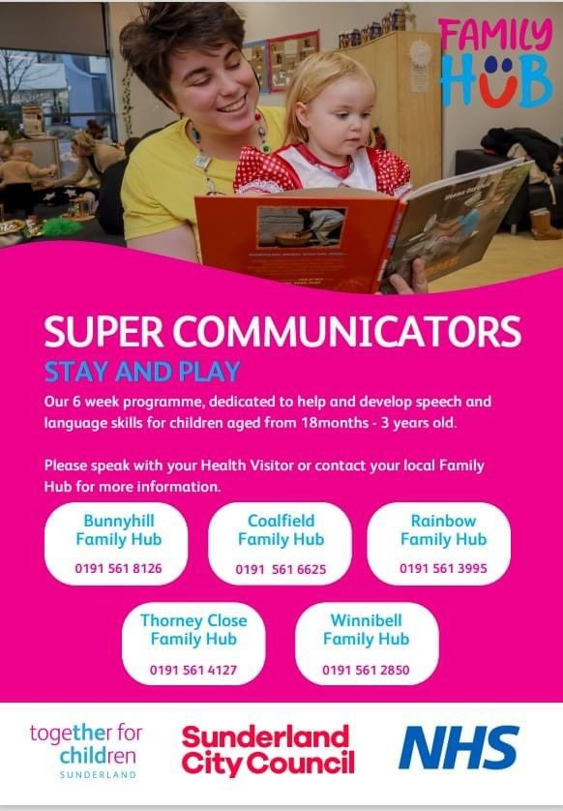
For any families with little ones aged 18 months to 3 years, together for children offer a 6 week stay and play programme to help develop speech and language skills. Speak to your health visitor or contact a local family hub (see flyer below) for more information.

Thank you for your continued support and positive feedback and comments that we receive.

Mrs M.Graham Mrs A.Toward

Executive Head Teacher Head of School

